Name: Ravin Godbole
PRN: B25CE1087
Div: CE 2, Batch A
-------------------------------------------------------------------
Experiment name: Display Student Grade
Topic: IK Rating

IK Rating Program

Aim: -

The aim of this report is to introduce the concept of IK rating and to create a program to identify the IK rating of an object

Research: -

An IK rating (Impact Protection rating) is an international standard classification (from IK00 to IK10) for electrical equipment that indicates the degree of protection an enclosure provides against external mechanical impacts.
Before the use of IK ratings, a third numeral was added to the ingress protection rating (IP rating) for example IP66(9).
This nonstandard use was one of the main factors that lead to developing the IK ratings.
The IK Rating standard came into effect in 1995.
The higher the number, the greater the resistance to impacts.
IK Ratings are measured in Joules, using specialized hammers to simulate real-world conditions.
Reasons why IK Ratings are important: -
1.Durability: - IK Ratings quantify a product’s ability to withstand impact.
2.Cost Savings: - A higher rating reduces the likelihood of costly repairs or replacements.
3.Public Safety: - In Public spaces, preventing damages avoids potential hazards like exposed wiring or broken parts.
4.Functional Reliability: - These are essential devices present in areas prone to vandalism or accidents, ensuring they continue to function as intended.

References: -

1. https://cie-group.com/how-to-av/videos-and-blogs/ik-ratings
2. https://www.lumascape.com.au/ik-ratings
3. https://www.polycase.com/techtalk/learningcenter/ik-ratings

Analysis: -

The IK rating scale ranges from IK00 to IK10, with each higher no. indicating an ability to withstand a greater level of impact.
IK00: No protection
IK01: Protected against 0.14 joules of impact. Equivalent to the impact of a 0.55 lb (0.25 kg) mass dropped from 2.2" (56 mm) above the impacted surface
IK02: Protected against 0.2 joules of impact. Equivalent to the impact of a 0.55 lb (0.25 kg) mass dropped from 3.2" (80 mm) above the impacted surface
IK03: Protected against 0.35 joules of impact. Equivalent to the impact of a 0.55 lb (0.25 kg) mass dropped from 5.5" (140 mm) above the impacted surface
IK04: Protected against 0.5 joules of impact. Equivalent to the impact of a 0.55 lb (0.25 kg) mass dropped from 7.9" (200 mm) above the impacted surface
IK05: Protected against 0.7 joules of impact. Equivalent to the impact of a 0.55 lb (0.25 kg) mass dropped from 11.0" (280 mm) above the impacted surface
IK06: Protected against 1 joule of impact. Equivalent to the impact of a 0.55 lb (0.25 kg) mass dropped from 15.8" (400 mm) above the impacted surface
IK07: Protected against 2 joules of impact. Equivalent to the impact of a 1.1 lb (0.5 kg) mass dropped from 15.8" (400 mm) above the impacted surface
IK08: Protected against 5 joules of impact. Equivalent to the impact of a 3.75 lb (1.7 kg) mass dropped from 11.8" (300 mm) above the impacted surface
IK09: Protected against 10 joules of impact. Equivalent to the impact of a 11.0 lb (5 kg) mass dropped from 7.9" (200 mm) above the impacted surface
IK10: Protection against the highest level of impact, which is 20 Joules.

Ideate: -

How the Rating is determined: -
1. The IK Standard: - The test method is defined by the international standard IEC 62262.
2. Testing Equipment: - The standard specifies the use of different impact hammers, which are designed to deliver a specific amount of energy.
3. Standardized Conditions: - The testing is conducted under specific atmospheric conditions and with the enclosure mounted in a defined way.
4. The Test: - A standard hammer strikes the enclosure to deliver a calibrated impact. For example, a device must withstand the impact of a 5kg mass dropped from 400mm to achieve an IK10 rating.

Build: -

The code for the problem is as follows: -

#include<stdio.h>
int main()
{
int n, i;
float imp;

printf("Enter no. of objects: ");
scanf("%d", &n);

for (i=1; i<=n; i++)
{
printf("Enter the amount of impact against which the object is protected (in joules, between 0 and 20) : ");
scanf("%f", &imp);

if
(0<imp&&imp<=0.14)
{
printf("\nIK Rating is IK01\n");
}
else if
(0.14<imp&&imp<=0.2)
{
printf("\nIK Rating is IK02.\n");
}
else if
(0.2<imp&&imp<=0.35)
{
printf("\nIK Rating is IK03.\n");
}
else if
(0.35<imp&&imp<=0.5)
{
printf("\nIK Rating is IK04.\n");
}
else if
(0.5<imp&&imp<=0.7)
{
printf("\nIK Rating is IK05.\n");
}
else if
(0.7<imp&&imp<=1)
{
printf("\nIK Rating is IK06.\n");
}
else if
(1<imp&&imp<=2)
{
printf("\nIK Rating is IK07.\n");
}
else if
(2<imp&&imp<=5)
{
printf("\nIK Rating is IK08.\n");
}
else if
(5<imp&&imp<=10)
{
printf("\nIK Rating is IK09.\n");
}
else if
(10<imp&&imp<=20)
{
printf("\nIK Rating is IK010.\n");
}
else
printf("\nInvalid Input\n");
}
return 0;
}

Testing: -

Test Case 1: -
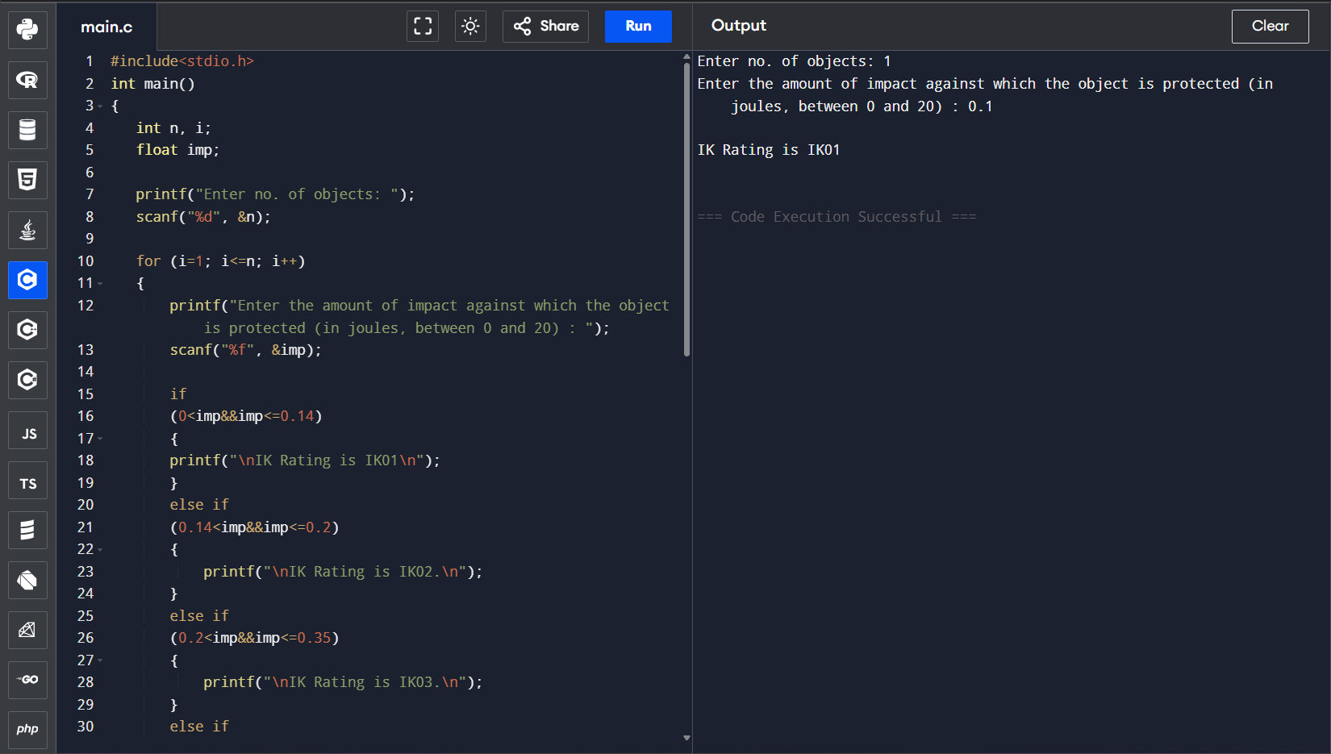

Test Case 2: -
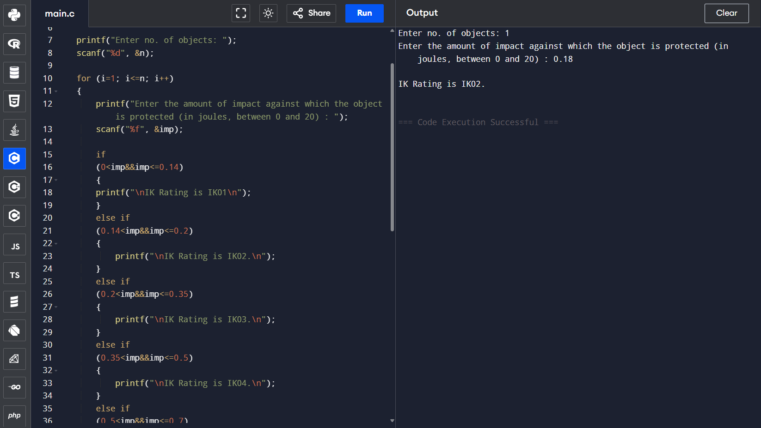

Test Case 3: - 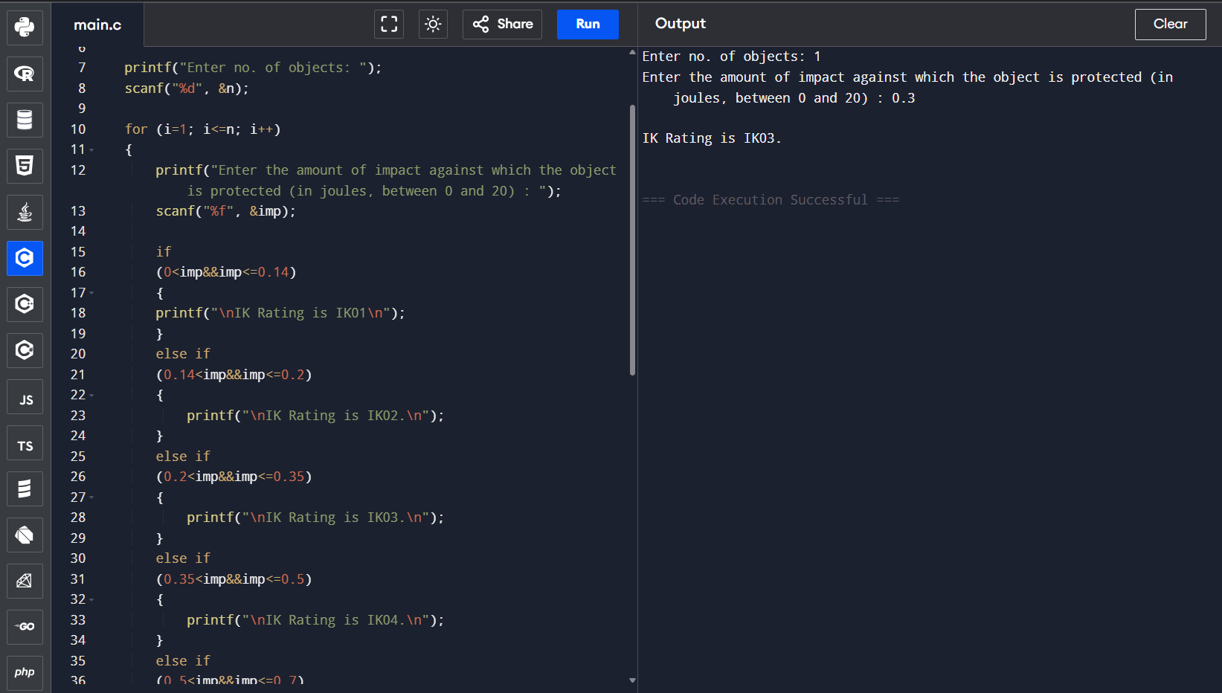: -

Test Case 4: -
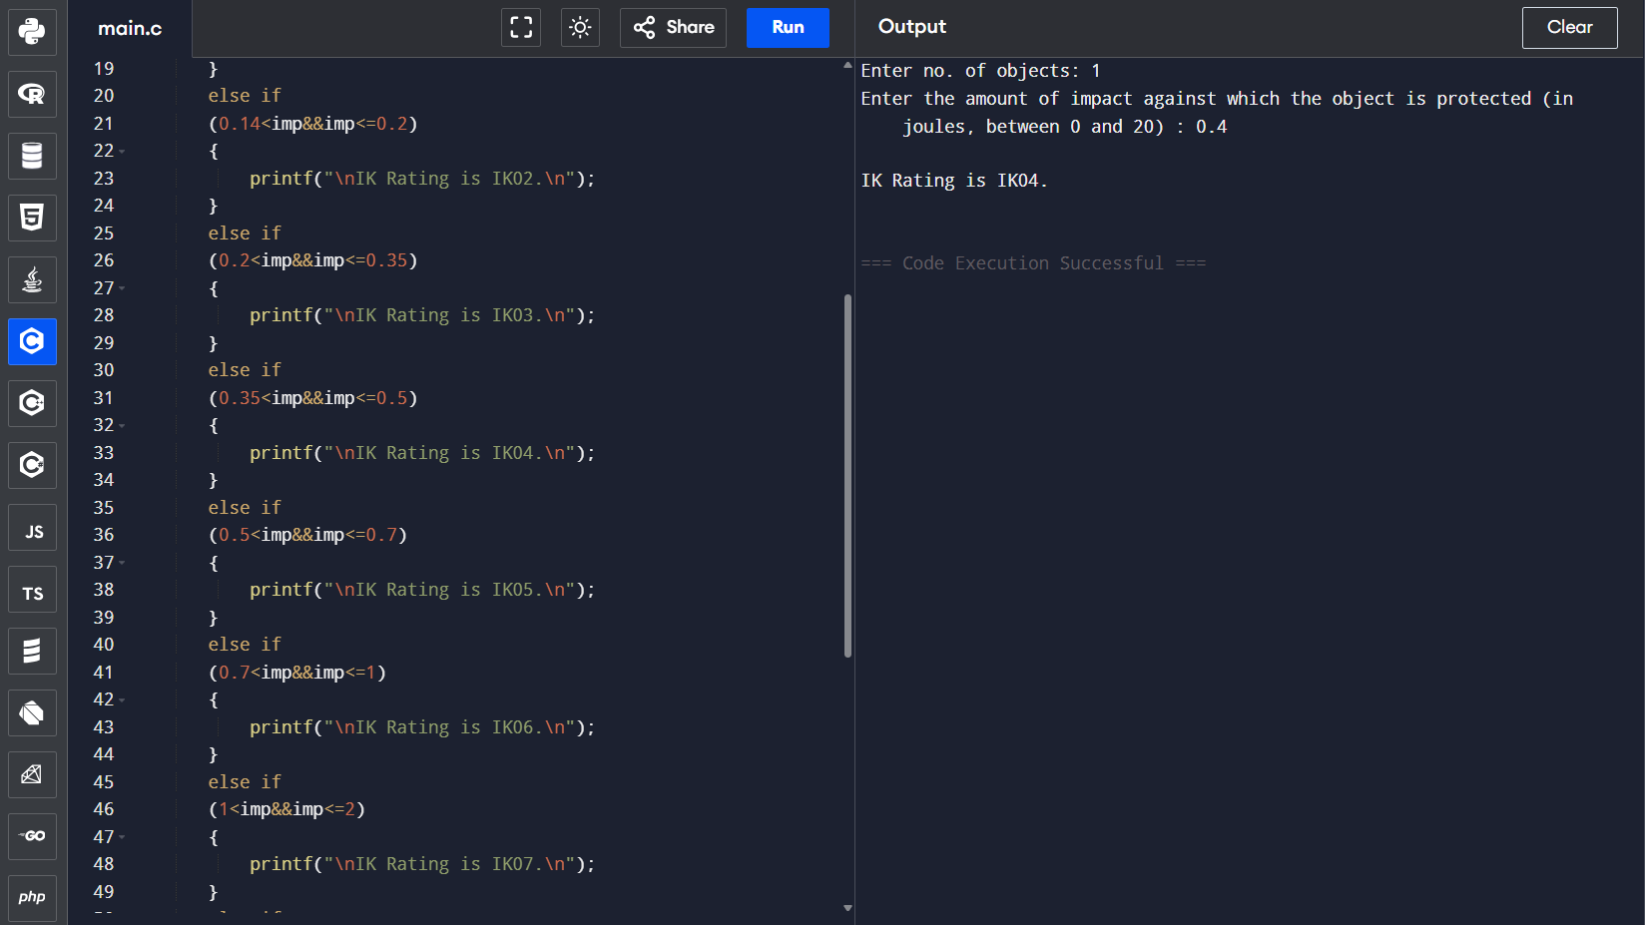

Test Case 5: -
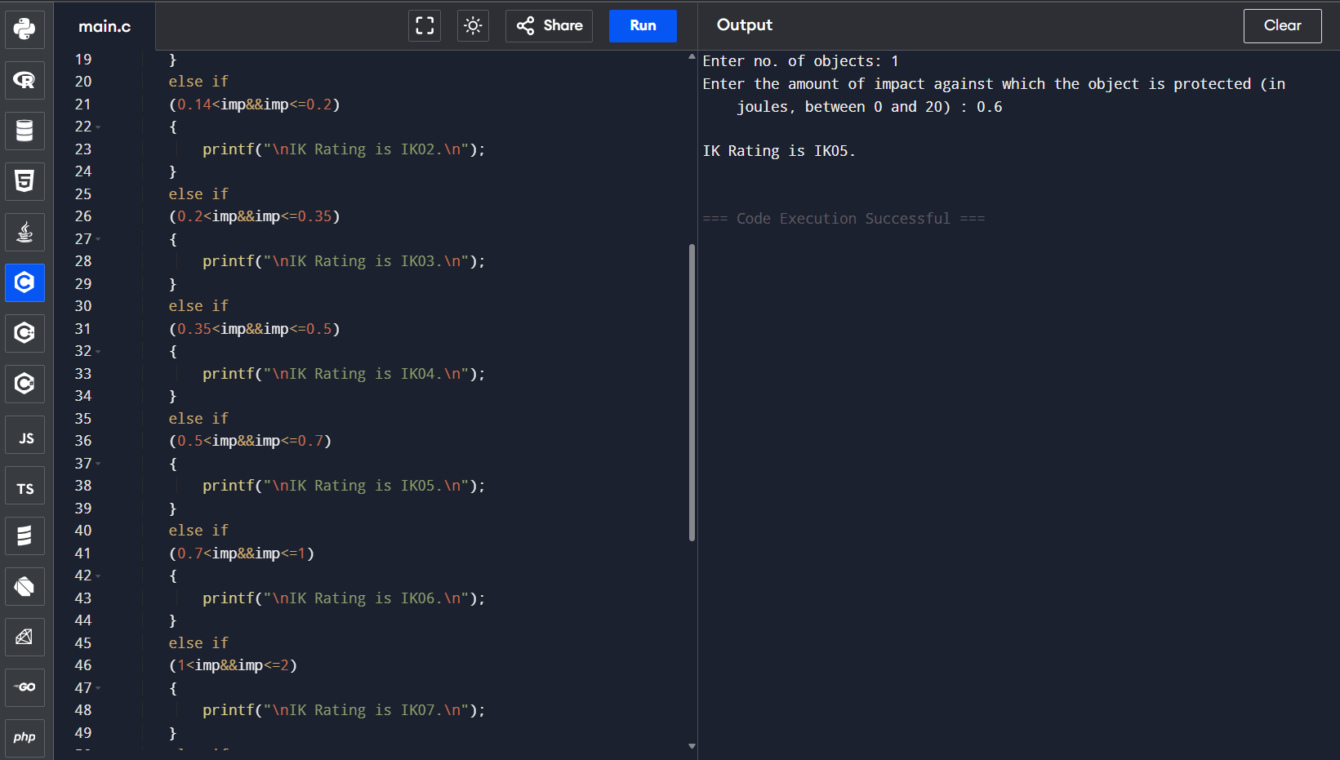

Test Case 6: -
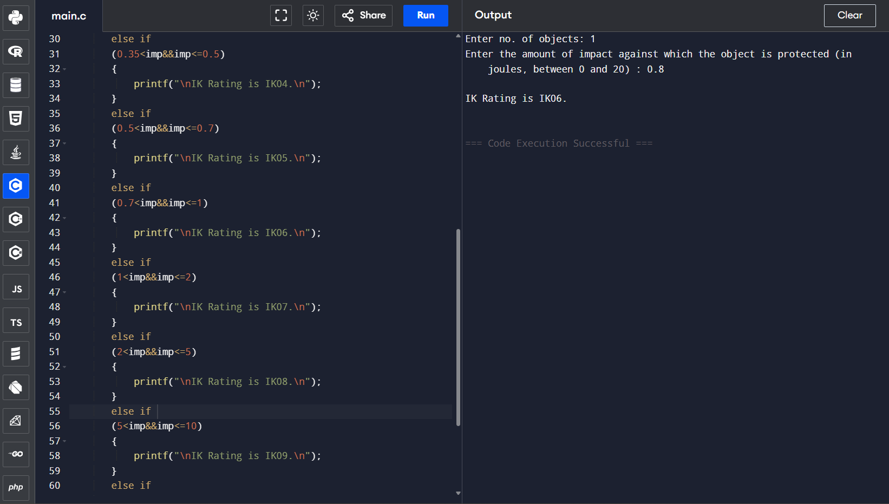

Test Case 7: -
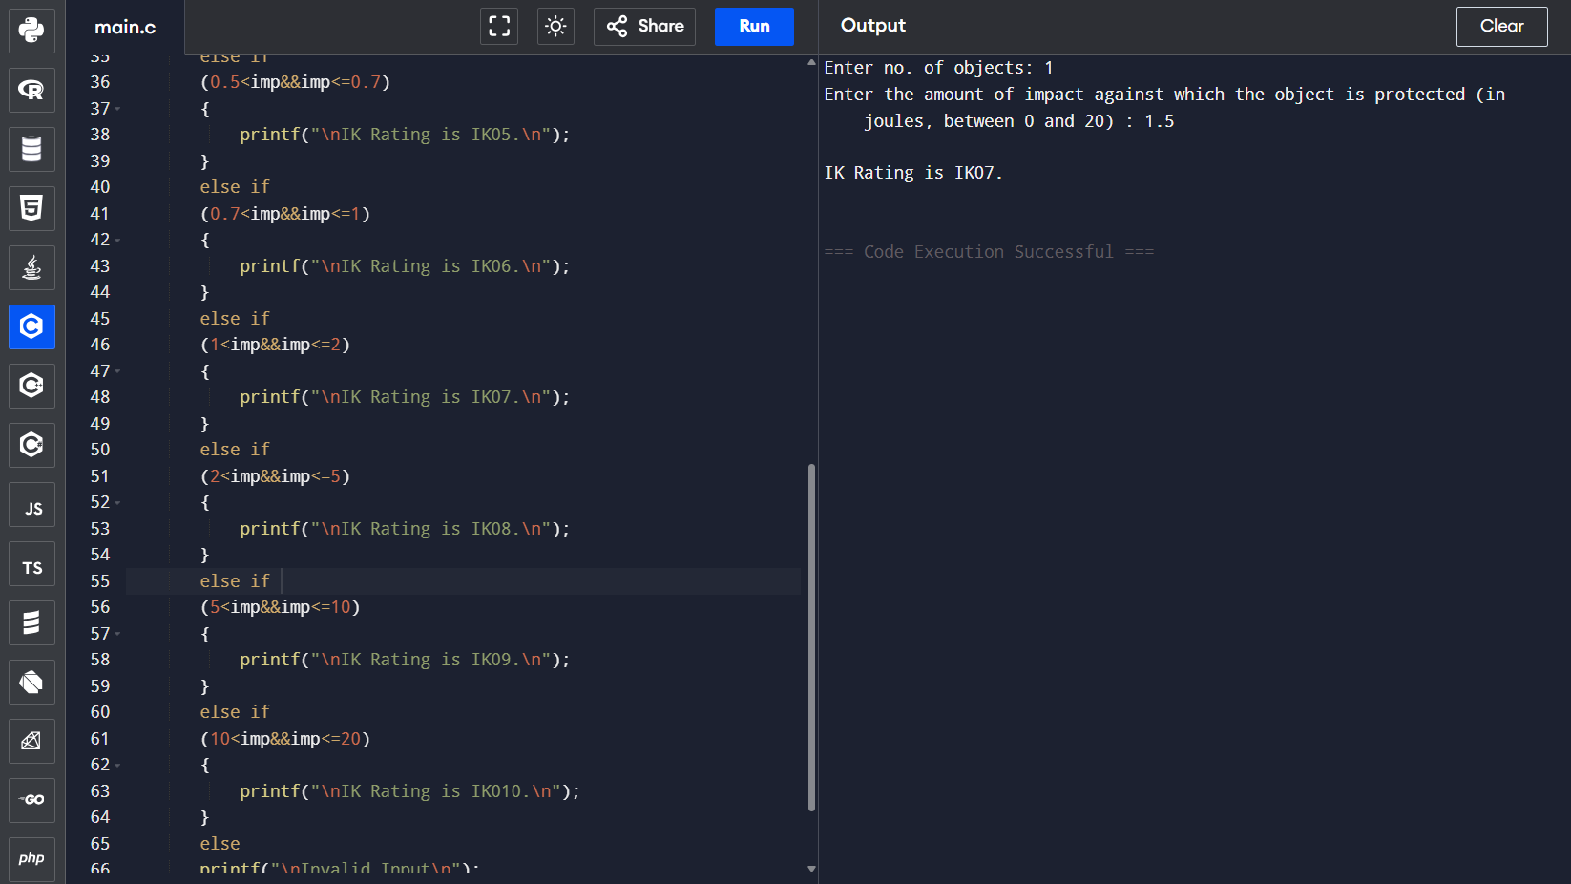

Test Case 8: -
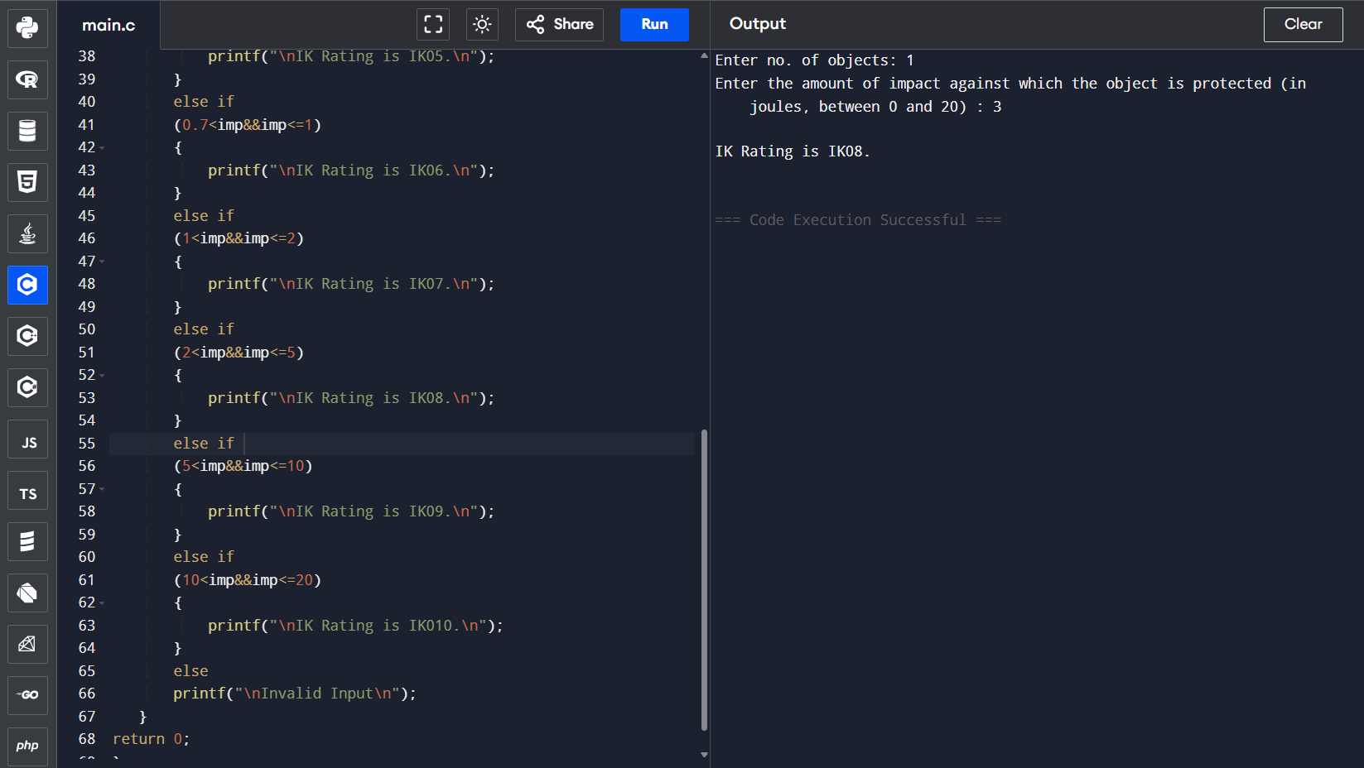

Test Case 9: -
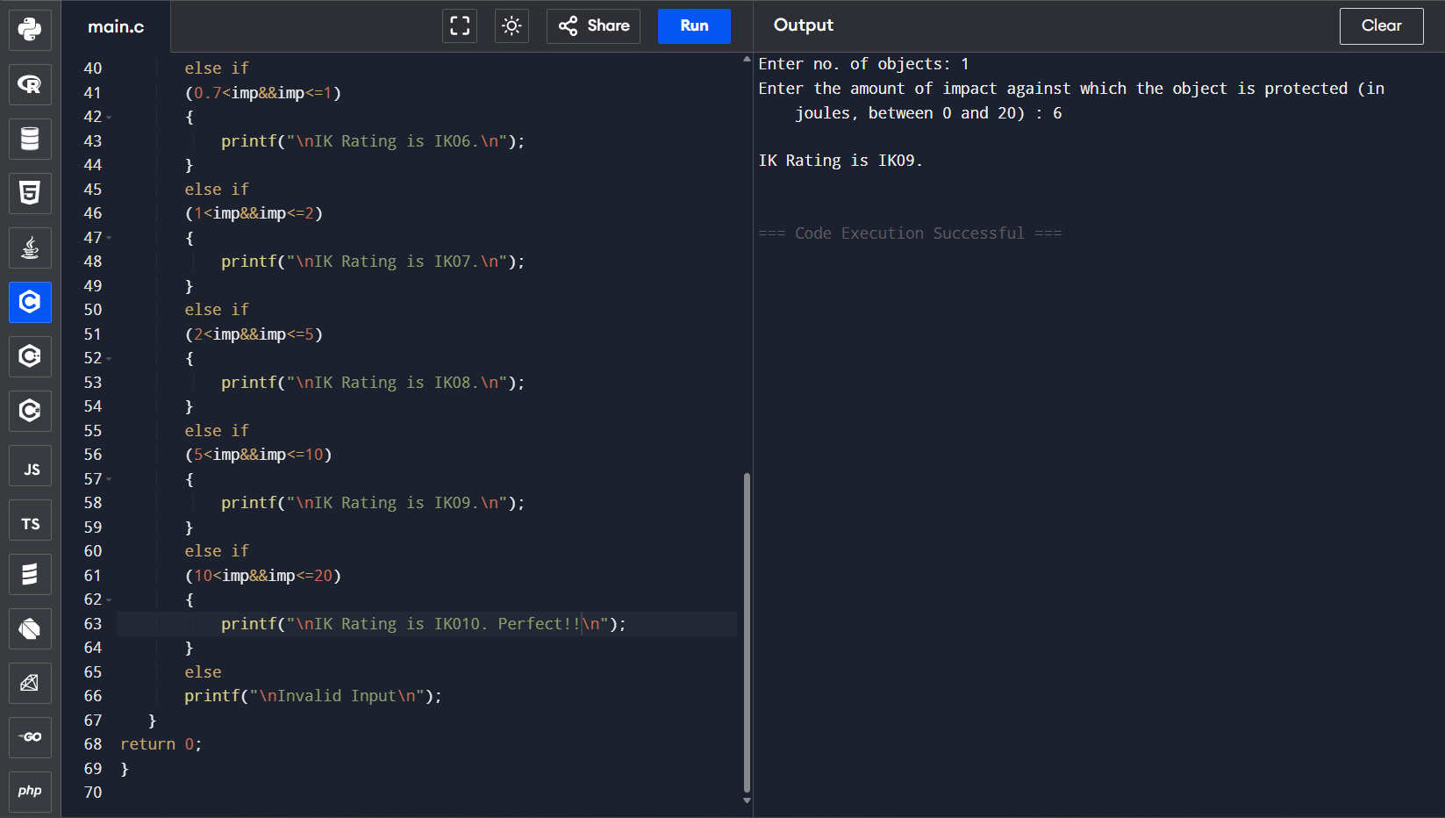

Test Case 10: -
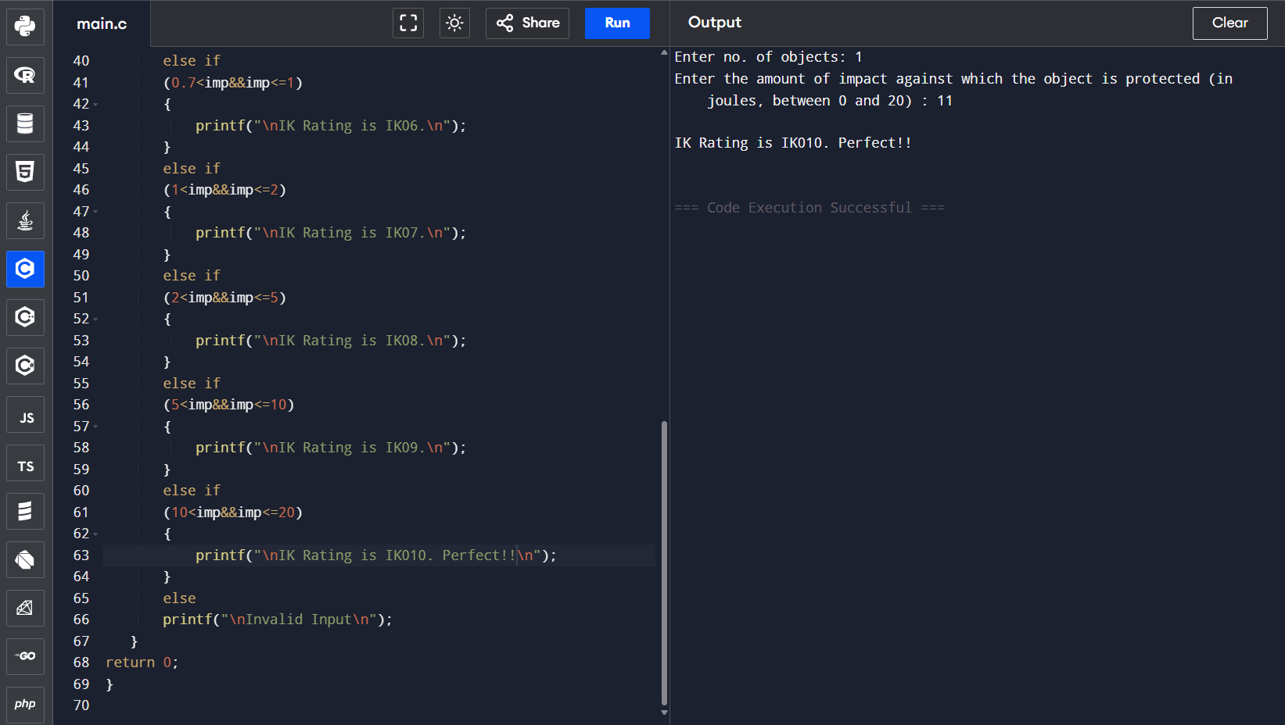

Test Case 11: -
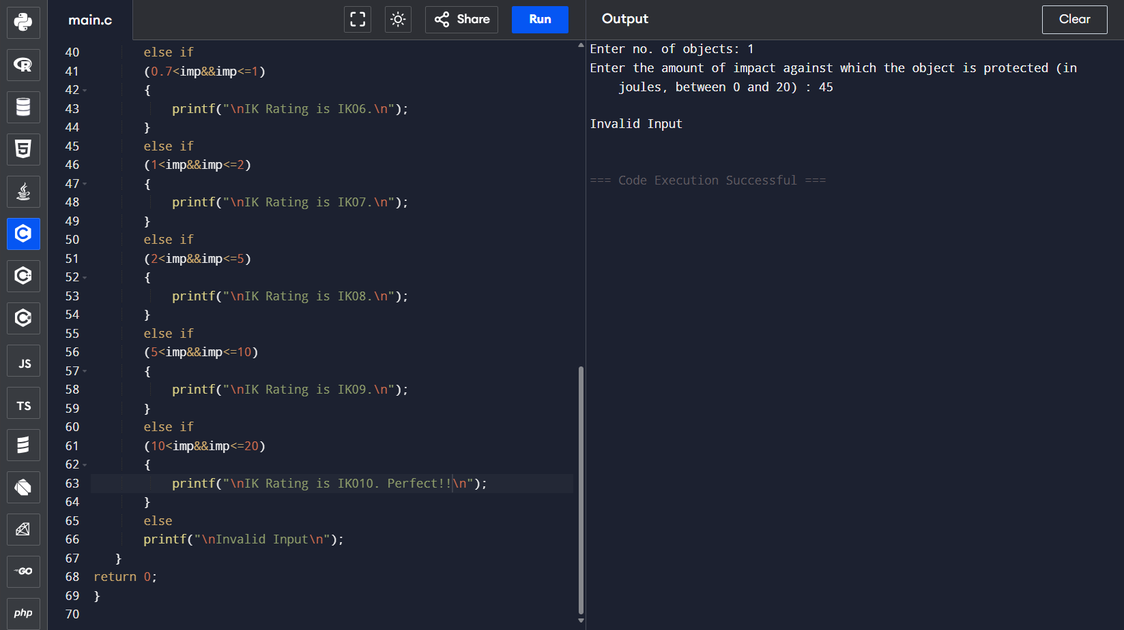

Link: -

https://github.com/Ravin-dev-129/IK_rating

Conclusion: -

Thus, the code is functional as shown by the test cases above and so we have completed our objective.

